Keney Park Sustainability Project – Information Sheet

<Date>

Keney Park
Address: 183 Windsor Ave, Windsor, CT
(Corner or Windsor Ave and Norman Ave - Directly across from Sunoco/Shell Station)

Agency Contacts
Primary: Herb Virgo 860-833-9828 herb@familydayhartford.com
Backup: Henry Hester 860-614-2523

<Company> Contacts
Captain | # of Volunteers | Work# | Cell#

Directions
Link to Google maps: Keney Park Map - Park entrance is just off Exit 34 from I-91
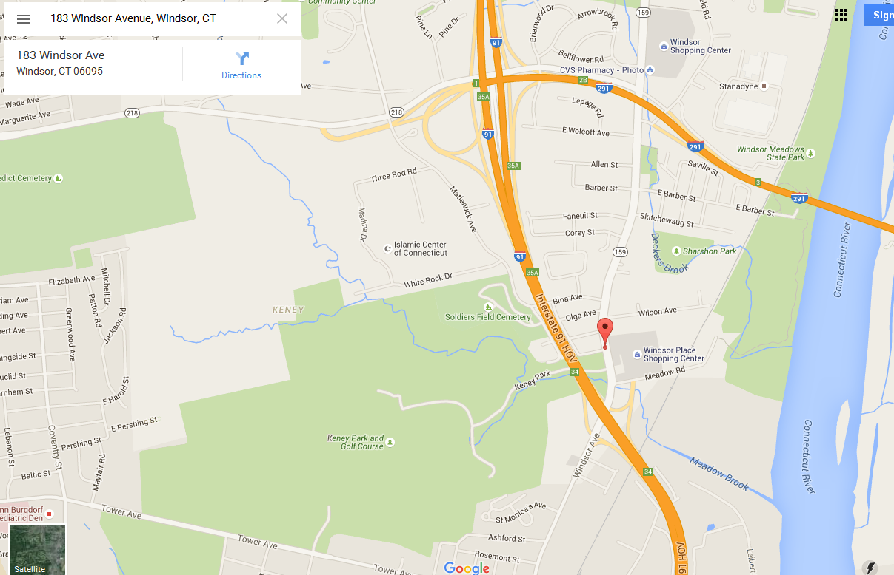
)
Parking ( ) – Proceed into the park and on the left and right sides of the road. Parking is allowed in these areas only during volunteer events. (For events with less than 50 volunteers)
- Park Entrance – just off 183 Winsor Ave
- Upper Parking lot accommodates 80-90 cars (for events with 50 or more volunteers)
- Ride-sharing is strongly suggested

Accessibility
Full Rest rooms are available in the Windsor Ave park entrance area.
A single Port-o-let is available in the upper parking area (bring wet wipes or hand sanitizer).

Volunteer Arrival /Departure/Activity Timetable

Timeframe | Activity
 | Note: All Waivers must be signed prior to commencing work
*Activities could wrap up earlier based on assigned project completion.

What to Wear? (Be sure to wear your Year of Caring t-shirt)
- REQUIRED: Long pants and closed toe shoes
- Work gloves (some will be available/provided) – highly recommended to bring your own
- Long sleeve shirts and safety goggles might be a plus for those working on clearing brush on the trails
Back-up plan for inclement weather (if necessary)
- ___________________

Food Logistics – Captains are providing
- Breakfast: _______________________________________________________________
- Lunch: _________________________________________________________________
- Beverages: ______________________________________________________________

Tasks
With the assistance of The City of Hartford Youth Service Corps we will be working on the following projects:
CAUTION: THERE IS POSION IVY possible in the woods, so LONG PANTS AND LONG SLEEVE SHIRTS REQUIRED! IVY BLOCK is a great idea to bring and apply before you get started.

1.______________________________________________________________________
2.______________________________________________________________________
3.______________________________________________________________________
4.______________________________________________________________________
5.______________________________________________________________________

Things to bring

1.____________________________
2.____________________________
3.____________________________

If you bring your own tools, please label them.
Please bring your own work gloves (some available)
Bug Spray, IVY BLOCK, Sunscreen, hat, Safety goggles are all a plus!

Captain’s Note Page

Meet before the event with Herb to visually inspect work project areas and responsibilities – scheduled for <date / time>
Day of the event (optional)
xxx – Bring lemonade, ice tea mix
xxx – bring 2 orange beverage coolers filled with water/ice
xxx – soda (diet) – xx cans
xxx – soda (regular) – xx cans
xxx – water (xx bottles)
xxx – coffee (xx regular, xx decaf)
xxx – First Aid Kit
xxx – xx cold drink cups
xxx – roll of paper towels
xxx – wet wipes/hand sanitizer, napkins
xxx – signs for “Trash” and “Recycle”
xxx – folding tables (to set up lunch) – work with Herb to see what’s needed
xxx – Bring coolers with ice (each work location should have a cooler with water). Rolling coolers work great!
Note: Gas station across the street from park entrance has ice for purchase
Captains - secure management pre-approval for lunch, beverage and any other costs to be expensed (estimated cost $$). Post event, split charges based on participant GL/Department ID.
Each Captain – in charge of their own team volunteer check-in
- Waivers must be signed prior to event
  - <company> Photo Release Waivers – give to company contact
- Bring extra waivers / pens day of event

Herb will put up signs at Windsor Ave entrance and guide them to parking area.

Additional Notes: ________________________________________________________________________________________________________________________________________________________________________________________________________________________________________________________________________________________________________________________________________________________________________________________________________________________________________________________________________________________________________________________________________________________________________________________________________________________________________________________________________________________________________________________________________________________________________________________________________________________________________________________________________________________________________________________________________________________________________________________________________________________________________________________________________________________________________________________________________________________________________________________________________________________________________________________________________________________________________________________________________________________________________________________________________________________________________________________________________________________________________________________________________________________________________________

